# Workshop - Forms

This application is created as a workshop for the [VueJS Course](https://softuni.bg/trainings/2820/vuejs-march-2020) @ [Software University](https://softuni.bg)

# Task Requirements

You will be provided with skeleton (**HTML**, **CSS**)

Your Task is to create a **registration form** and add **validation** to each field of the form.

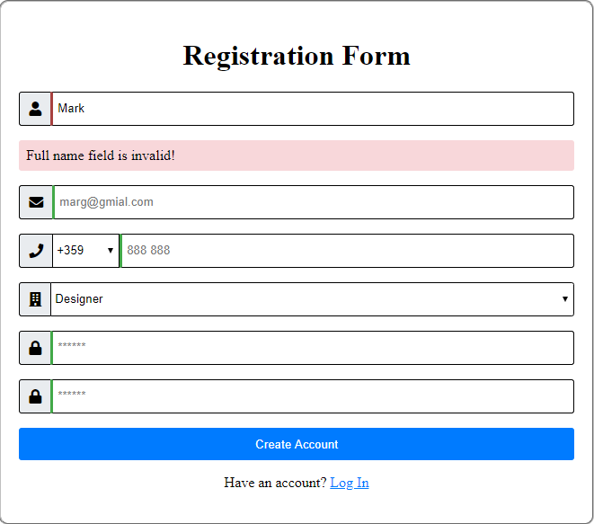

### Validation

* The full name input field must contain **two names** (letters only) separated by a **space**. Both should start with a **capital** letter.
* The email input field must be a **valid email** address.
* The phone number input field must be a **9-digit** number.
* The **select list** with **options** should contain only the **following** **professions** – Accountant, Designer, Software Engineer, Manager, Other
* The password input field must be between **3** and **16** **symbols** and must contain only **letters** and **digits**.
* Both passwords must **match**.

### Output Messages

Output error messages inside a **div** with class **"error"** when an input field is **invalid** and **touched,** also **disable** the **submit button** if an input field is invalid.



If an input field is **invalid**, you should also add the class **"error"**